Experiment – 6

Hospital Managemnet System:
To design and deploy a Hospital Management System as a Software as a Service (SaaS) application using Zoho Creator for efficient management of hospital operations.
PROCEDURE:
1.Log in to Zoho Creator with a valid account and initiate the development process by creating a new application from scratch, enabling full customization of the hospital management framework.
2.Develop a Patient Details form to systematically record essential patient information such as name, age, gender, contact details, address, medical history, and admission status to ensure accurate patient record management.
3.Create a Doctor Details form to maintain comprehensive information about doctors, including their specialization, department, availability schedule, and contact details for effective resource allocation.
4.Design an Appointment or Treatment Details form and integrate it with both the Patient Details and Doctor Details forms using lookup fields, thereby establishing a structured relationship between patients and assigned doctors for consultation and treatment tracking.
5.Configure automated workflows within the application to update appointment status, manage admission and discharge details, calculate billing charges based on treatment or consultation, and generate due payments efficiently.
6.Publish and deploy the completed application as a cloud-based service, allowing authorized hospital staff to securely access, update, and manage records online.
7.Upon successful configuration and deployment, the cloud-based Hospital Management System is fully developed and operational for real-time use.

IMPLEMENTATION:

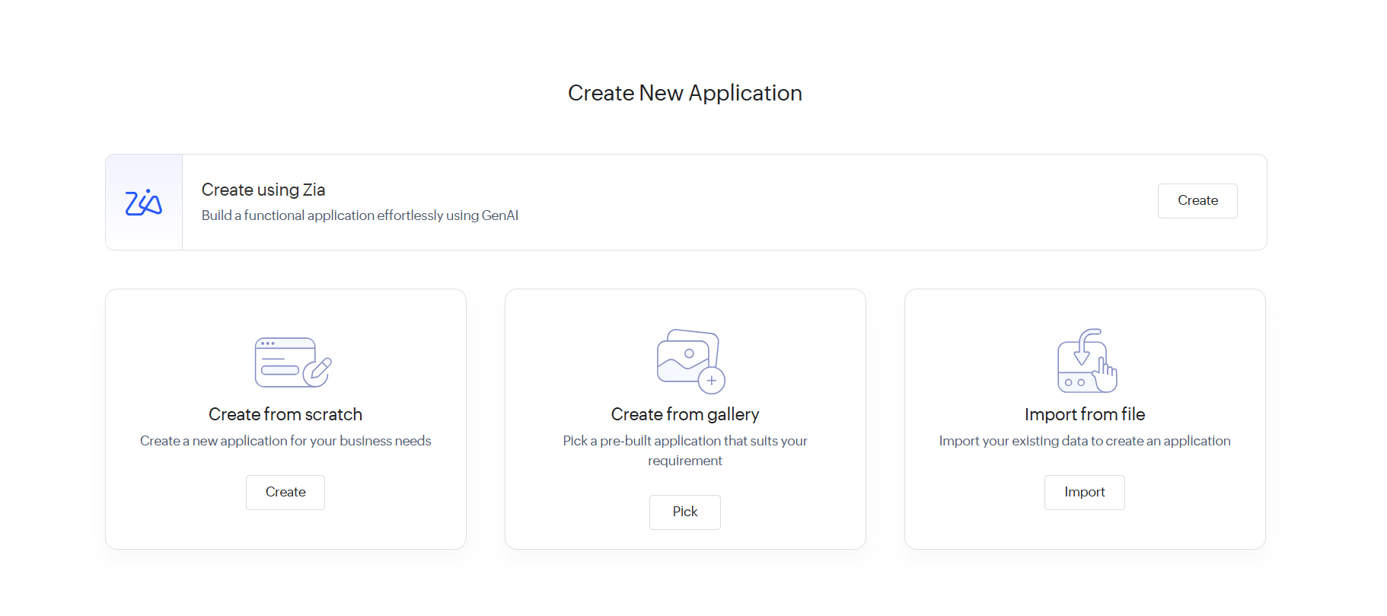

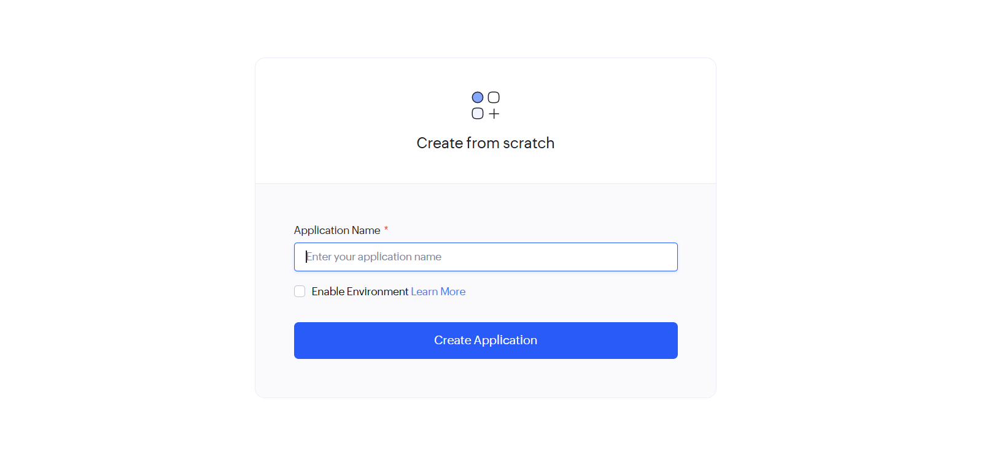

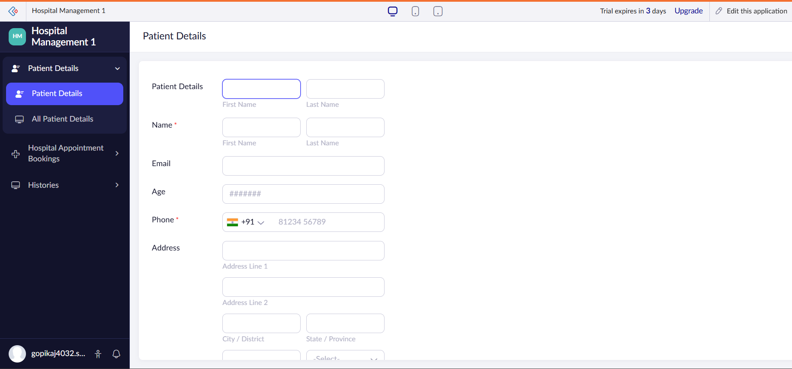

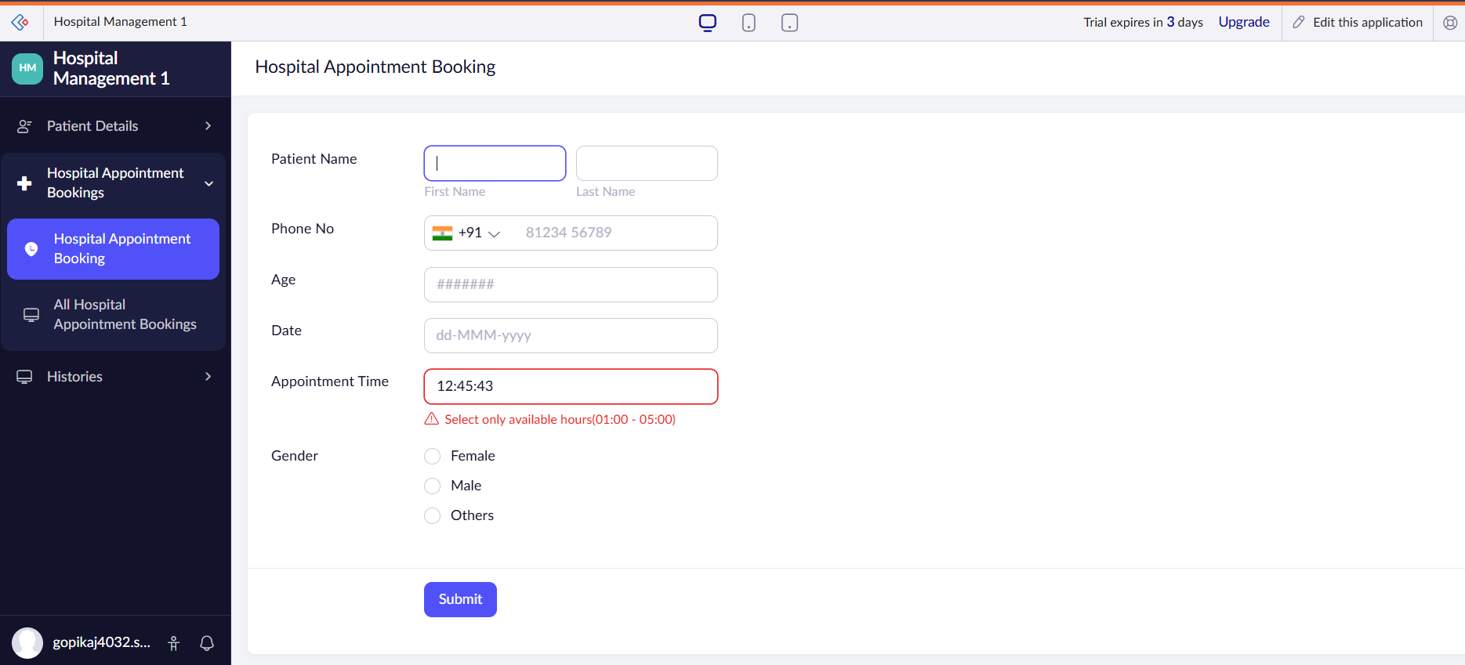

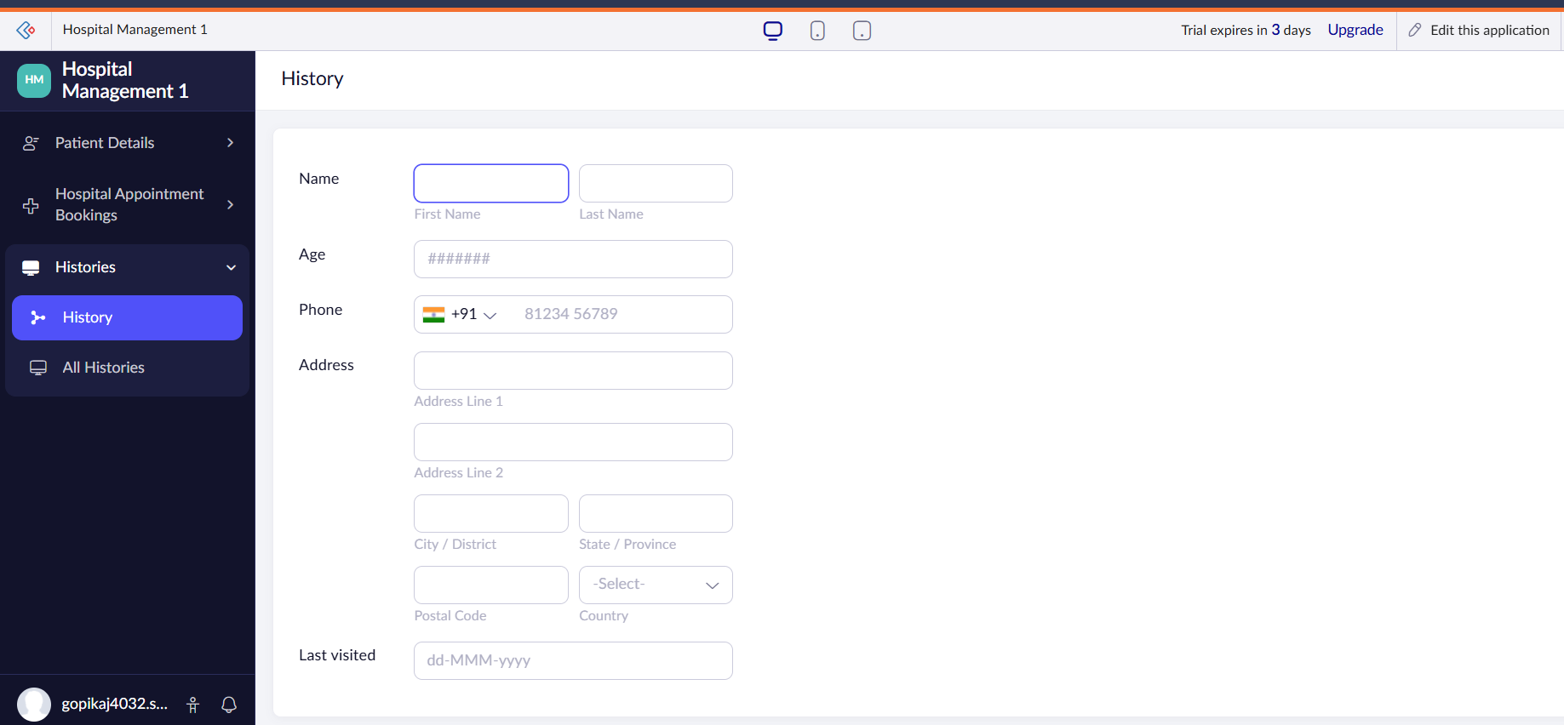

RESULT:
The Hospital Management System was successfully designed and deployed using Zoho Creator as a cloud-based SaaS application. The system effectively manages patient records, doctor information, appointments, treatments, and billing processes through structured forms and automated workflows.

